PrintVendo:
Wi-Fi-Enabled Portable Printer with Coin Vending Payment System

A Capstone Project Proposal
Presented to the College of Engineering and Technology
Holy Cross of Davao College
Davao City

by

Honnie Mae Pilletero
Dave Andrew Arafol
John Paul Pendo

October 2024
Table of Contents
Page
INTRODUCTION 1
Background of the Study 1
Rationale 2
Objectives of the Study 4
Scope and Delimitation of the Study 5
Review of Related Literature 6
Conceptual Framework 18
METHODOLOGY 20
Project Concept 20
Description of the Project 20
Entity Relationship Diagram 23
Schematic Diagram 24
Methods 26
Research Respondents 27
Research Environment 27
Research Instrument 27
Data Collection 27
Data Analysis 28
Ethical Considerations 31
REFERENCES 37

List of Figures
Figure 1. Conceptual Framework of the Study 18
Figure 2. Deployment Diagram 22
Figure 3. Entity Relationship Diagram (ERD) 23
Figure 4. Schematic Diagram 24
Figure 5. System Flowchart 25
Figure 6. System Development of the Study 26

INTRODUCTION

Background of the Study
In Universiti Tun Hussein Onn Malaysia, students have experienced a variety of issues with the current printing services that are present on their campus (Dickenn et al., 2019). They must first decide which printing stalls best suit their needs and are in a handy location. They have to inspect several printing stalls as part of this process, which takes time and effort. The restricted availability of printing services is another major obstacle. It is challenging for students to always have access to printing services because the majority of printing booths are only open during business hours and are closed on holidays. In situations when students must print materials after regular business hours, this restriction may pose a special challenge.
A study conducted by Tan et al. (2019) used Discrete Event Simulation, a well-known evaluation system performance under various configurations and to conduct what-if analysis, assessing the impact of proposed changes before implementation. In their study, they applied the DES model to a real case scenario of a printing shop at Universiti Utara Malaysia, which faces long queues during peak hours. Using Arena software version 14.5, the study analyzes the shop's queuing system to identify potential bottlenecks. Their goal is to explore alternative solutions for providing faster printing services to customers.
Additionally, a study by Ahmed et al. (2020) investigated the efficiency of printing services at Universiti Teknologi Malaysia. The research employed a mixed-method approach, combining quantitative surveys and qualitative interviews to gather comprehensive data from students and staff. The study found that the primary issues were not only the limited operating hours but also the frequent technical malfunctions of the printers and inadequate customer service. Ahmed et al. recommended implementing a centralized printing management system to streamline the operations, enhance service reliability, and provide extended hours of operation, potentially through automated kiosks.
Similarly, Chua et al. (2021) conducted a study at Universiti Sains Malaysia, focusing on the environmental impact of current printing practices. Their research highlighted the excessive use of paper and ink, prompting the need for more sustainable printing solutions. They proposed the integration of digital submissions and cloud-based printing services to reduce waste and promote eco-friendly practices among students and staff. Their study also suggested the adoption of energy-efficient printers and the implementation of a comprehensive recycling program for used paper and cartridges.
Furthermore, Lim et al. (2022) explored the potential of mobile printing solutions at Universiti Malaysia Pahang. Their study utilized a pilot program to assess the feasibility and user acceptance of mobile printing applications, which allow students to send print jobs directly from their smartphones or laptops to any available printer on campus. The pilot program showed promising results, with high user satisfaction and a significant reduction in wait times, as students no longer needed to queue at specific printing stations. Lim et al. concluded that mobile printing could be a viable solution to enhance accessibility and convenience for students, especially during non-business hours.
In conclusion, these studies collectively underscore the need for universities to adopt innovative and efficient printing solutions to address the various challenges faced by students. Implementing centralized management systems, extending operating hours, adopting sustainable practices, and leveraging mobile technology can significantly improve the overall printing service experience on campus.

Rationale
In the current rapid-paced digital age, the need for convenient and efficient printing solutions has become increasingly important. Many individuals, including students, professionals, and job seekers, frequently need hard copies of documents for various purposes. For students, this might include submitting assignments, projects, and thesis papers. Professionals may require printed reports, presentations, or official documents for meetings and collaborations. Job seekers often need printed resumes and application forms for job interviews. However, traditional printing methods can be inconvenient, especially for those who do not have easy access to nearby printing facilities.
The development and implementation of a self-service coin-operated printing vending machine can address these issues by providing a readily accessible and user-friendly solution. Such machines can be strategically placed in educational institutions, public spaces, and commercial environments, ensuring that printing services are available to everyone, even outside regular business hours. This eliminates the need for individuals to travel to distant printing shops or wait in long queues, saving time and effort.
From a practical perspective, these vending machines offer a convenient and straightforward way for users to print documents on demand. Economically, they can be a cost-effective solution for institutions and businesses, reducing the need for staffed printing services and potentially lowering operational costs. Socially, they promote inclusivity by making printing services accessible to a broader audience, including those in underserved or remote areas.
This study aims to explore the practical, and social implications of implementing self-service coin-operated printing vending machines. By analyzing their impact in various settings, such as universities, libraries, shopping centers, and transportation hubs, the research will contribute valuable insights to several fields. It will assess how these machines can enhance user convenience, improve operational efficiency, and support the diverse printing needs of different user groups. Through this exploration, the study seeks to provide a comprehensive understanding of the benefits and challenges associated with this innovative approach to printing services.

Objectives of the Study
This study aims to develop a device by combining the technologies of both printer and coin slot machine to further augment the portability of printing services.
Specifically, this study aims to:
- Develop a device that can print documents and receive coins as payment by:
  - adding a microcontroller (Arduino Uno) that will govern the properties of both coin slot and coin hopper. The said microcontroller will act as the brain of the device that handles the input from the coin acceptor that is linked to the system that has connected to the printer.
- Create an interface for the users to configure the settings of the document to be printed according to their preferences through:
  - developing a system application in Visual Basic that will be deployed into a computer.
  - connect the said computer to a liquid crystal display (LCD) that has a touchscreen function. The LCD will project the deployed system, and will serve as the interface for users to configure their preferred option for printing.
- Create a mobile application that allows the administrator of this proposed device to track the weight of the paper of the printer inside the device through:
  - adding a load cell sensor inside the paper tray of the printer.
- Evaluate the acceptability of the device, and the app in terms of:
  - Performance Expectancy
  - Effort Expectancy
  - Social Influence using technology
  - Facilitating Conditions.

Scope and Delimitation of the Study
This study will primarily focus on designing and developing an Internet of Things (IoT) device that combines the technological properties of both printer and coin slot machine. The aim of the proposed device is to allow users to print, photocopy, or scan documents while inserting coins or bills into the coin slot as a mode of payment for using the device’s services. Also, along with the hardware development, a mobile application will be also developed specifically for administrators for this proposed device. This application will provide real-time tracking and monitoring of the printer’s status particularly the availability of papers for printing.
This study is delimited to the aforementioned forms of printing. Therefore, the researchers will not cover other forms of printing. Such as 3D printing, wide-format printing, or any other specialized printing techniques. As for the mode of payment, the coin and bill-based payment through coin slot machines will be the central focus of this study. The researchers ruled out the possibility of exploring other modes of payment to be included in this research. The users of this proposed IoT device will be those who require print, copy, or scan solutions in open or semi-open spaces. The study will not focus on personalization for specific users’ categories.
With these scopes leaving out definitive boundaries, the intention of the study lies in designing a practical and efficient IoT printing device embedded with the payment module and a managerial mobile application. Sustaining this focus will make it possible to achieve the goals within the available resources and timeframe of the project while addressing the particular needs that were established during the initiation of the project.

Review of Related Literature
E-Printing Service
In today's fast-moving world, time is a precious commodity, especially for college students who often find themselves standing in long queues for essential tasks like printing documents. To address this issue, (Bharadiya et al., 2020) proposed an innovative e-printing service designed to streamline the printing process. This service allows users to upload their documents online, make secure payments, and collect their printed copies at a convenient time without the need to wait in line. By integrating various modules to ensure efficiency and ease of use, the e-printing service aims to make the printing process more efficient and hassle-free, particularly during peak times like submission periods.
The e-printing service is designed to significantly reduce the time students spend on printing tasks, allowing them to focus more on their academic responsibilities. Students can simply upload their files, make the necessary payment, and have their documents ready for pickup at their specified time. This digital solution aligns with the broader trend of online services and digital transformation in various industries, including printing. (Bharadiya et al., 2020) emphasize the importance of secure payment methods, ensuring that files are queued for printing only after payment is made, making the process seamless and reliable.
In this study, (Bharadiya et al., 2020) utilized Microsoft Visual Studio as their integrated development environment (IDE) to develop the website. Alongside Visual Studio, they employed SQL (Structured Query Language) to manage and manipulate the data stored in a relational database. SQL is a standard language designed for querying and managing data within relational databases, making it essential for handling and organizing data efficiently. (Bharadiya et al., 2020) stated that by using their web application, students can easily get their documents printed without waiting in line. To use the application, users need to register by filling out a form with the necessary details such as enrollment number, name, email ID, phone number, password, stream, and semester. Once registered, users will have access to their dashboard, where they can view their personal information and print history. To send a document for printing, users can upload it through the "send document" feature, which only accepts PDF files to avoid issues with formatting and alignment that often occur with Word documents. Before sending, users can preview the file to ensure its accuracy. The system will automatically calculate the number of pages and determine the cost, which must be paid before submitting the file. The print request will appear on the shopkeeper’s system, and once the shopkeeper presses the "OK" button, the printing process will begin. The user will receive a notification that the printing has started, allowing them to collect their print without waiting in line.
(Bharadiya et al., 2020) concluded that the "E-printing service" will be highly beneficial for college students, as it eliminates the need to stand in long queues at printing shops, saving them a significant amount of time. By using E-printing, the queues will become shorter, reducing crowding in these areas. This service allows users to send their documents to the nearest printing station and conveniently collect their prints, making the process more efficient. It's a modern and practical solution for printing in public spaces. Currently, this type of service is not widely implemented in colleges, where many students need to print documents regularly. Introducing this service would greatly benefit both students and staff, helping them work more efficiently.
E-Commerce Website for Offset Printing
The e-commerce website for offset printing developed by (Gujarathi et al., 2024) offers a comprehensive platform for customizing and ordering printed products such as visiting cards, wedding cards, and doctor prescriptions. Customers can input their details, upload custom designs, and receive the final product at their home. The system emphasizes high-quality printing, offering options like paper thickness, glossiness, and color brightness. It also provides design flexibility, quick delivery, and a sample proof sent to customers via email for approval before finalizing the order, ensuring customer satisfaction and reducing errors.
(Gujarathi et al., 2024) observed the gaps that are present in the offset printing industry. They found out that customers face numerous challenges when purchasing offset printing products in person. These challenges include traveling long distances to buy products, dissatisfaction with product quantity or pricing, repeated visits to the store for proof checks, product corrections, and collections, and ultimately, dissatisfaction with the final product design. As a result, customers often encounter various frustrations related to purchasing offset printing products.
Experiences like this are the reason why the popularity of offset printing products is slowly decreasing. To address the said gaps, (Gujarathi et al., 2024) created a website for offset printing. Their goal is to provide enhanced offset printing services. Allowing customers to easily purchase products online without experiencing disappointment or inconvenience. The website they created also catered additional services, such as home delivery and custom design options, to make the process smoother.
The development of this website was driven by the need to improve upon existing systems that offer minimal services and customization options. (Gujarathi et al., 2024) identified several shortcomings in the current market, such as the lack of design customization, proofing services, and detailed product and machinery information. By addressing these gaps, the new e-commerce website aims to provide a more user-friendly and efficient service, ultimately enhancing customer satisfaction through better product offerings, secure payment options, and a streamlined ordering process.
Analyzing Customers’ Waiting Time Using Discrete-Event Simulation: A Case Study in A University Printing Shop
In their detailed investigation, (Tan et al., 2019) delve into the intricate dynamics of customer waiting times at a university printing shop, employing discrete-event simulation (DES) as a pivotal analytical tool. The study underscores the pervasive challenge of managing queues in service environments characterized by fluctuating demand and finite resources. Traditionally, queuing theory has provided theoretical frameworks to optimize service systems, focusing on mathematical models to predict and enhance operational efficiency (Tan et al., 2019). However, the complexity of real-world scenarios often necessitates more dynamic approaches like DES, which simulates events in real-time to identify bottlenecks and evaluate potential improvements in system performance (Tan et al., 2019).
By leveraging Arena software version 14.5, the researchers construct a simulation model tailored to the specific context of the university printing shop. This model aims not only to diagnose existing inefficiencies contributing to extended wait times during peak hours but also to explore alternative configurations that could expedite service delivery without compromising quality. Through what-if analyses, the study anticipates the impact of proposed changes, thereby facilitating informed decision-making aimed at enhancing customer satisfaction and operational outcomes in the university printing shop environment (Tan et al., 2019).
The printing shop that (Tan et al., 2019) conducted research operates on weekdays from 10 a.m. to 4 p.m. Offering a variety of services such as photocopying, printing, hardcover binding, and laminating. (Tan et al., 2019) primarily focused on the queuing process for the printing service. The shop provides four computers at the front desk for customers to download their materials for printing. Upon arrival, customers must wait in line to use the computers before proceeding with their printing tasks. After completing their printing, they move to a designated area at the front desk to make payments.
At the end of their analysis, (Tan et al., 2019) stated that a total of approximately 81 customers entered the system, with an average total time spent of 20.3532 minutes. The process involved waiting in line for service in the printing area, making a payment, and exiting the system after completing the service. Customers could proceed directly to the printing area if any of the four computers were available. However, if all computers were in use, they had to wait in a queue. On average, each customer spent 4.3270 minutes waiting in the printing queue and 1.4824 minutes in the payment queue. The average number of customers in the printing and payment queues was about 2 and 1, respectively. After payment, 72 customers successfully exited the system, leaving 9 customers as work in progress. Additionally, the system resources were well-utilized, with utilization rates above 50%. Specifically, the utilization rates for computers 1, 2, 3, and 4 were 77.92%, 79.01%, 79.15%, and 79.08%, while staff utilization was 58.12%.
Moreover, four computers were available for customers to use for printing. The average total time spent in the system was 20.3532 minutes, which included 4.3270 minutes of waiting in the printing queue and 1.4824 minutes in the payment queue. After adding an additional computer (as shown in Table 5), the average total time in the system decreased to 16.6407 minutes per customer, with the average waiting time in the printing queue dropping to 0.6475 minutes per customer. As expected, the utilization rate of each resource also declined to around 60%. The average number of customers in the printing queue decreased from roughly two customers to just one. This reduction in the queue will create a more comfortable waiting environment for customers, as the waiting area can now accommodate fewer than 15 people at a time.
In their conclusion, (Tan et al., 2019) suggested that the printing shop should add 1 more computer. Increasing the number of resources from four to five computers significantly reduced the average waiting time in the printing queue to 0.6475 minutes per customer. Implementing this change could improve the overall customer experience when using the services at the printing shop.
Print It to Me Development System
In their study, (Dickenn et al., 2019) examine the existing challenges faced by students at Universiti Tun Hussein Onn Malaysia (UTHM) regarding printing services on campus. The current system requires students to locate the most suitable printing stall or shop, often leading to inconvenience and inefficiency. Many students prefer self-service printers to avoid supervision, while others face difficulties due to limited operating hours and the need to physically visit multiple stalls to find the best service (Dickenn et al., 2019).
To address these challenges, the authors propose the development of a web-based system called "Print It to Me." This system aims to streamline the printing process by allowing individuals or organizations with printers to offer their services online, thereby enhancing accessibility and convenience for students. By providing an online platform, their research seeks to eliminate the need for physical surveys of printing stalls, offer services beyond typical working hours, and reduce the likelihood of printer misuse (Dickenn et al., 2019). The "Print It to Me" system is designed to create a more efficient and user-friendly printing environment on campus.
In their system, there are two types of users: customers and service providers (SP). Customers can request document printing by uploading their files and selecting printing preferences, with their details needed during registration (Dickenn et al., 2019). They receive notifications when their documents are printed and delivered, and they can also provide feedback on the website. On the other hand, service providers can view a list of pending customer requests and choose which to fulfill. Once the printing is done, the SP contacts the customer to arrange delivery.
During their implementation phase, (Dickenn et al., 2019) used ASP.NET as the platform, while writing the codes in C#. C# is responsible for the backend portion of their website, while HTML is utilized to design the frontend. Additionally, the system includes a built-in SQL Server Data Tools database for managing data.
After developing the website, (Dickenn et al., 2019) performed functional testing to test the functionality of the website. The website matches the testing’s expected result; therefore, the website was considered successful. (Dickenn et al., 2019) found limitations on their research that could be solved in the future studies. Limitations such as the website being exclusive only to UTHM. And, the website’s web server does not have a more secure connection to safeguard data in the system. (Dickenn et al., 2019) stated that if other researchers were to continue their study, they should focus on providing suitable solutions to the aforementioned limitations.
Coin-Operated Vendo-Wi-Fi Machine
In their study, (Rosario 2019) developed an intelligent Wi-Fi vending machine designed to offer more accessible and cost-effective internet connectivity while ensuring security and fair use. The device utilizes a wireless local area network connection and a multi-coin acceptor to facilitate user access. The setup involves connecting a router to the Wi-Fi using an Ethernet cable, wiring the components to the Raspberry Pi 3's GPIO pins, and powering the system. Users connect to the machine's hotspot, receive login credentials via SMS upon inserting a coin and entering their mobile number, and then use these credentials to access the internet (Rosario 2019).
In their study, (Rosario, 2019) developed an intelligent Wi-Fi vending machine designed to offer more accessible and cost-effective internet connectivity while ensuring security and fair use. The device utilizes a wireless local area network connection and a multi-coin acceptor to facilitate user access. The setup involves connecting a router to the Wi-Fi using an Ethernet cable, wiring the components to the Raspberry Pi 3's GPIO pins, and powering the system. Users connect to the machine's hotspot, receive login credentials via SMS upon inserting a coin and entering their mobile number, and then use these credentials to access the internet (Rosario 2019).
The study's results indicate a clear relationship between the distance from the machine and the speed of the internet connection. Proximity to the machine significantly enhances connection speed, while greater distances result in slower internet performance. Statistical analysis using Analysis of Variance (ANOVA) revealed a significant difference in internet speed at varying distances (5, 10, and 15 meters), with a p-value of 0.0238, which is below the alpha threshold of 0.05. This finding led to the rejection of the null hypothesis, confirming that distance from the machine substantially affects connection speed (Rosario 2019).
Design and Implementation of Automated Printing Press Software
(Ejiofor, 2018) studies have highlighted persistent delays in print jobs, often due to the operator not completing typesetting on time or the designer failing to send the design to the publisher promptly. These recurring delays in print shops create significant inefficiencies and can lead to missed deadlines, which are detrimental to business operations and customer satisfaction. Such issues underscore the need for a more structured and reliable system to manage print jobs and ensure timely completion. The lack of effective communication and tracking mechanisms exacerbates these delays, making it difficult for print shops to operate smoothly. To provide a suitable solution to the aforementioned problems.
(Ejiofor, 2018) developed a website designed to manage print jobs more efficiently. The website tracks the progress of print jobs in real time, detecting any delays and notifying print production managers to take corrective actions. By providing detailed insights and timely alerts, the website enables managers to intervene early and prevent delays from escalating. This proactive approach helps to maintain a smooth workflow and significantly reduces the number of print jobs that miss deadlines. The primary users of this software are expected to be print production managers, customers, and print shop staff, all benefiting from improved workflow, better communication, and timely job completion.
(Ejiofor, 2018) used HTML and CSS for designing the frontend of their website. And PHP was used for the backend to link the website to a database. Also, instead of using traditional IDEs, (Ejiofor, 2018) used Notepad++ text editor because it supports the aforementioned languages very well. They also implemented Entity Relationship Diagram (ERD) on their website by using MySQL that is a built-in feature of installing XAMPP.
After their implementation stage, (Ejiofor, 2018) conducted a software testing to find hidden bugs in their website. And, also to test the functionality of the website ensuring that the website met the required functionalities. (Ejiofor, 2018) concluded that their website was used in an actual printing shop. It is expected that the website will be an effective implementation. And that it will significantly reduce the number of delays that can occur in a printing shop.
ARDUINO-BASED COIN-OPERATED RESTROOM PROTOTYPE
In their research, (Abapo et al., 2023) address the issue of limited restroom accessibility during non-working hours, which is often due to the absence of security staff responsible for collecting fees. This situation has led to a recent decline in the availability and accessibility of public restrooms, as these facilities frequently remain closed when staff are not present (Abapo et al., 2023). Additionally, restrooms require maintenance fees to ensure cleanliness, with cleaning companies being hired to conduct regular checks. To tackle these challenges, (Abapo et al., 2023) propose the use of coin-operated systems similar to vending machines, which are known for their convenience, accessibility, and cost efficiency. These machines can operate around the clock without requiring a salesperson, thus offering a potential solution for 24-hour restroom access.
Their study revolves around creating an Arduino-integrated door lock system that enables the people/users to unlock the door of a restroom by inserting a 5-peso coin through a coin slot machine. After inserting a coin, The LCD will display a timer of 30 seconds. The user is bound to enter the restroom within that time frame. While doing so, the PIR Sensor that is placed inside the restroom will detect if there is a person inside the restroom. If a person is detected, the timer on the LCD will stop. And the user can now use the restroom.
(Abapo et al., 2023) performed testing on the functionality of their automated door lock system. The testing of the system’s functionality was mostly successful however, they were minor error glitches and errors found in the system. The result’s findings concluded that out of 10 test scenarios, 2 of which are unsuccessful, 8 of which are successful, however in those 8, 4 of them have minor glitches. In summary, the occurrence rate of error is 20%, while the occurrence rate of glitches is 40%.
In their conclusions, (Abapo et al., 2023) stated that the system shows promise as an effective solution for managing public restrooms, though further research is required to address its limitations and assess its feasibility on a larger scale. According to their study's findings, the Arduino-Based Coin-Operated Restroom Prototype presents a viable option for managing restroom usage in public spaces. Its accuracy, reliability, and ease of use make it a strong alternative to traditional restroom management methods.
Monitoring 3D Printer Performance using Internet of Things (IoT) Application
Industries and daily life are changing as a result of 3D printing and the Internet of Things (IoT) (Li et al., 2017). IoT enables the collection and exchange of data by connecting physical objects—devices, cars, buildings—with electronics, sensors, and software. With an anticipated 50 billion linked things by 2020, this leads to more precise and efficient systems with significant economic benefits. Meanwhile, (Li et al., 2017) Stated that 3D printing is becoming more and more common, particularly with open-source designs like RepRap printers. Usually powered by computers or microprocessors, these printers can now be remotely controlled and monitored more effectively thanks to the Internet of Things. An IoT application to monitor 3D printer performance—including print progress and temperature control—was designed as part of a student project that investigated this concept.
This study led by (Li et al., 2017) is a multidisciplinary project. Their goal is to create and provide students access to both 3D printer and IoT platform, as well as get experience working with engineers from various fields to solve challenging engineering issues. The project's goal is to create and develop an IoT software for remotely tracking a RepRap 3D printer’s operation, such as printing development as well as the heated bed's and hot end's temperatures. Major tasks associated with the project are to examine and improve the present 3D printer in order to prevent any potential compliance problems. between the IoT application's hardware elements or software tools and the 3D printer; to link the Raspberry Pi computer to the 3D printer, as well as to create and expand the Internet of Things usage.
In their design stage, the printer that (Li et al., 2017) used was custom designed. This 3D printer was designed based on the RepRap Wallace printer. On the other hand, the IoT platform that (Li et al., 2017 utilized in this project was the PTC ThingWorx Technology Platform, it offers a comprehensive range of integrated tools and features specifically designed to support the development of IoT applications. Their project consisted of four (4) major tasks. First was the upgrading of their 3D printer, second was the process of connecting the said printer to the microcontroller of their choice, which was Raspberry Pi 3. Third task was to develop and design an IoT application with a ThingWorx composer. And the fourth task was to set the entire system for a functional testing—to test the basic functionalities of the newly created system. Their project had a duration of nine (9) months and is still ongoing. Moreover, (Li et al., 2017) stated that although the system is not finished, they argued that it is feasible to remotely monitor a RepRap's performance using an Internet of Things application 3-D printing device.
IoT-Based 3D Printer Development for Student Competence Improvement
(Prianto et al., 2021) stated that a 3D printer is a practical example of equipment that operates based on the principles mentioned earlier. 3D printers are becoming increasingly common as educational tools, requiring specific skills and competencies to use effectively. A major challenge for students in adopting 3D printing technology is the lack of equipment and technical knowledge in many universities. The 3D printer design being developed incorporates modern computing technology and aims to teach students not only how to operate the equipment but also how to design and program objects using it.
(Prianto et al., 2021) aims to develop an IoT-based 3D printer as a learning tool for CNC maintenance and repair, identify the competencies supported by this technology, and explore its implementation in enhancing student skills within the Mechatronics Engineering Education program. The research employs a Research and Development approach using the ADDIE model, which includes Analysis, Design, Development, Implementation, and Evaluation. The results indicate that the IoT-based 3D printer has been tested for functionality and feasibility, making it suitable for educational purposes to improve the competencies of students in the Mechatronics Engineering program.
In their planning stage, (Prianto et al., 2021) stated that using filament-based G-code designs, the 3D printer employs additive manufacturing; a Raspberry Pi acts as a bridge to provide internet connectivity. This configuration enables cloud storage for G-code design data as well as the control and data retrieval necessary for IoT functionality, such as monitoring camera feeds, process percentages, and operating temperatures. Installed on the Raspberry Pi using its own operating system, Octoprint controls USB data retrieval and enables 3D printing connectivity (Prianto et al., 2021). Through the use of a router/modem, a local network allows PCs and cell phones to function as Octoprint's controllers for Internet of Things 3D printing systems. Design data is also stored in the cloud, and users may access the IoT 3D printing system remotely from any internet-connected device by using third-party software called The Spaghetti Detective (TSD). This means that the system is accessible from beyond the local network (Prianto et al., 2021).
(Prianto et al., 2021) concluded that IoT-based 3D printers can assist with learning CNC maintenance and courses on repair that cover pertinent subjects including configuring a 3D printer, the CAM process, and of employing a 3D printer to print products. This instrument can be utilized by means of operation or control via the internet in order to facilitate online learning.

Conceptual Framework
PROCESS

- Selection of Preferred Service (Print, Scan, Photocopy)
- Selection of printing type and other options

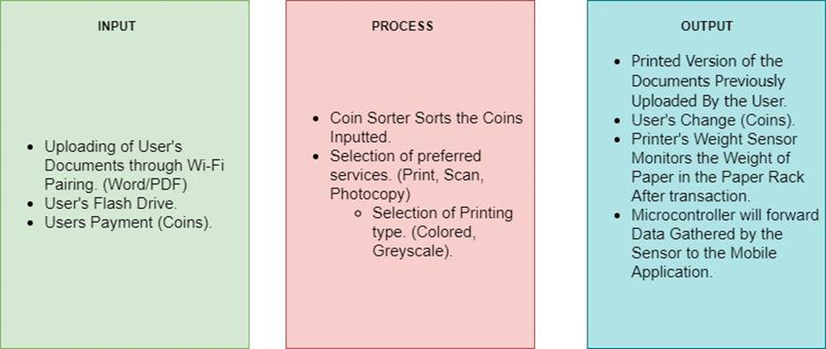
Figure 1. Conceptual Framework of the Study
Figure 1 presents the conceptual framework for the study “PrintVendo: Wi-Fi-Enabled Portable Printer with Coin Vending Payment System.” This comprehensive framework outlines the development process through three key stages: input, process, and output. In the input stage, the focus is on defining the initial requirements and resources necessary for the system. This includes hardware and software specifications, user requirements (both functional and non-functional), the development of a test plan, and the creation of survey instruments. The process stage involves the actual development and testing phases, encompassing IoT device development, mobile application development using the waterfall development model, system testing, and user acceptance testing.
Finally, the output stage highlights the expected results and the final product, which includes the fully developed PrintVendo: Bluetooth-Enabled Portable Printer with Coin Vending Payment System and the conduction of user acceptance testing to ensure the system meets user needs and expectations. This framework provides a clear and structured roadmap for the future development of the PrintVendo system, ensuring that each stage of the process is thoroughly planned and effectively implemented.

METHODOLOGY
In this section, we explore the core ideas and methods behind the project, providing a clear overview of its design and the steps taken throughout its execution. This explanation not only highlights the guiding principles that shaped the project but also offers insight into the practical strategies employed to bring the project to life. By outlining the approach in detail, we aim to give a deeper understanding of the thought process and planning that went into each phase of the project’s development.

Project Concept

Description of the Project
The proposed project ‘PrintVendo’ is an innovative automated printing device designed to meet the essential document processing needs of users in various settings such as libraries, universities, and office spaces. The core functionality of PrintVendo revolves around providing convenient and efficient services for printing, photocopying, and scanning documents. While allowing administrators of the proposed project to track maintainable contents of the printer inside the system. The unique features of PrintVendo are its integrated coin slot, which allows users to make payments using coins. And its mobile application that allows administrators to track the status of the printer inside the system by implementing IoT features. This payment system is designed to be user-friendly and accessible, ensuring that users can quickly and easily pay for the services they need without the need for digital transactions or card payments. This makes PrintVendo particularly suitable for environments where simple, cash-based transactions are preferred or more practical.
The primary goal of the PrintVendo project is to develop a reliable and versatile device that streamlines the document processing experience. Users will be able to print, photocopy, and scan their documents seamlessly, while the built-in payment system provides a straightforward method for service usage. By focusing on these essential functions, PrintVendo aims to address the common challenges faced in public and semi-public printing environments, such as accessibility, ease of use, and payment convenience. The development of this device will include the integration of modern printing technologies to ensure high-quality outputs, as well as the creation of a supporting mobile application for administrators. This application will enable real-time monitoring and management of the device, specifically tracking its maintenance needs.
List of functions in the System
- Print function
- Photocopy function
- Scan function
- Coin acceptor function
List of functions in the mobile application
- admin account function
- Notification function
- Sale history function
As for the specification of the mobile device, the minimum system requirements should meet the following:
- Operating System: Android or iOS
- RAM: at least 1 GB
- Storage: at least 1TB

Deployment Diagram
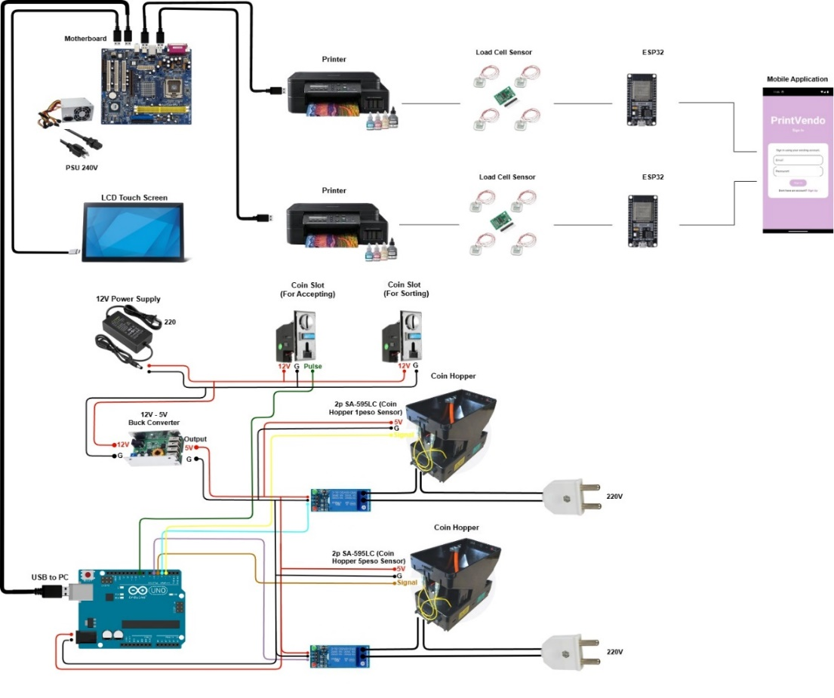
Figure 2. Deployment Diagram
Figure 2 shows the deployment diagram of the proposed device, PrintVendo, a coin-operated printing service. The diagram illustrates the interaction flow between users and the device. There are two types of users: (1) Consumers, who interact with the device to purchase its services, and (2) Administrators, who are responsible for monitoring the status and management of the device. Each user has their respective interface.
Consumers will interact with the device via a touch panel monitor, where they can configure settings for how they want their documents to be printed. Administrators, on the other hand, will access their interface through the system itself, where they can select additional options, such as pricing and other settings. Additionally, there is a mobile application integrated into the system. The primary purpose of this interface is to provide real-time tracking of the components within the printer that require regular maintenance, particularly the paper stored inside the printer.

Entity Relationship Diagram
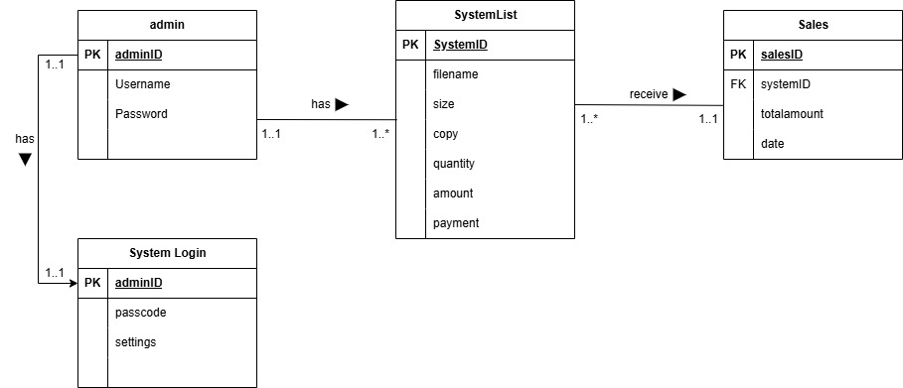
Figure 3. Entity Relationship Diagram (ERD)
Figure 3 shows the Entity Relationship Diagram (ERD) of the Print Vendo Machine System. The ERD consists of four entities: Admin, SystemList, System Login, and Sales. The 'Admin' entity represents the administrators who manage the system, with a primary key, adminID, uniquely identifying each admin. The 'SystemList' entity stores the details of print jobs, including attributes such as filename, size, copy, quantity, amount, and payment, with systemID as the primary key. The 'System Login' entity is used for authentication, linking admin login details through adminID as the primary key and attributes like passcode and settings. The 'Sales' entity tracks transactions, containing salesID as the primary key, systemID as a foreign key, and attributes such as totalamount and date of sale. The relationships depicted in the diagram show that the 'Admin' entity manages the 'SystemList,' which is associated with sales records in the 'Sales' entity.

Schematic Diagram
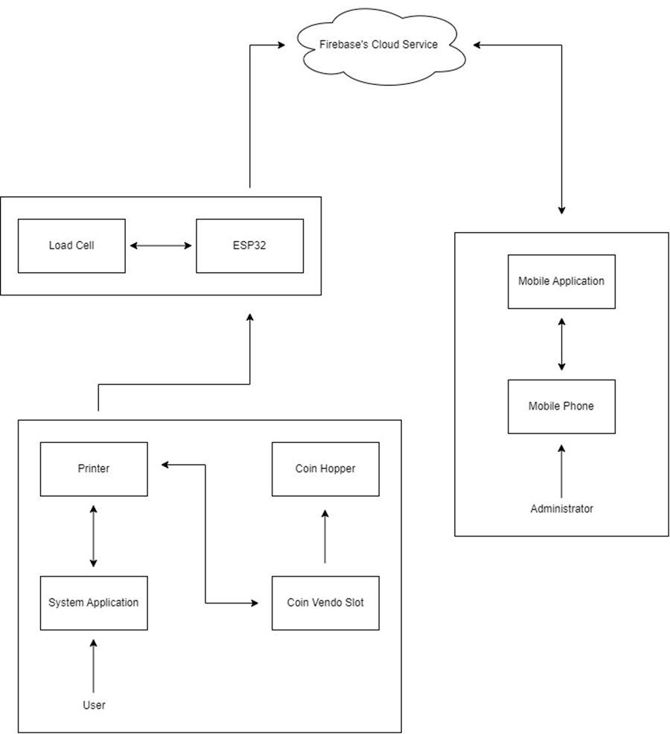
Figure 4. Schematic Diagram
Figure 4 illustrates the components that constitute PrintVendo. It integrates several key components to provide an efficient and user-friendly printing service. The mobile phone serves as the platform for the administrator's mobile application, enabling remote management and monitoring of the device. This application communicates with a cloud database, which acts as a central repository for all operational data and facilitates data exchange between the mobile app and the Arduino Uno microcontroller. The Arduino Uno, which governs the device's hardware, processes data from connected sensors such as the load cell and the coin slot, ensuring accurate measurements and payment verification.
Users interact with the PrintVendo device through a user interface system that allows them to configure their printing preferences. This interface provides an intuitive experience, enabling users to select print settings and initiate printing services. Overall, the PrintVendo device seamlessly combines remote administration, data management, hardware control, and user interaction to deliver a streamlined and effective printing solution.
System Flow
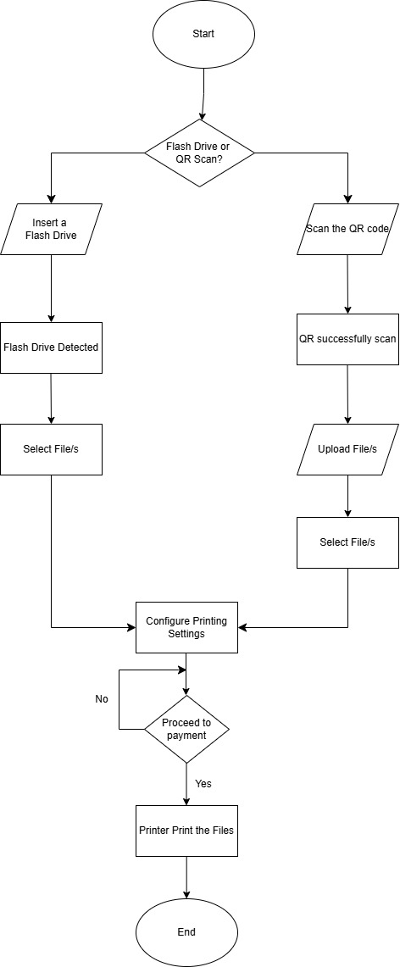
Figure 5. System Flowchart

Methods
Design of the Study
The study is a development-type study. Thus, the researchers will develop an application alongside data gathering and analysis. Furthermore, the study will use quantitative techniques to gather and analyze the data.
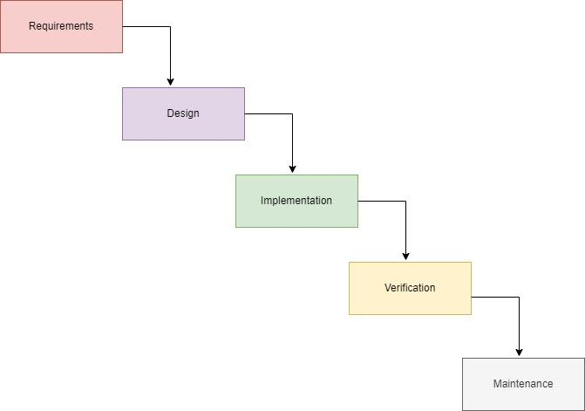
Figure 6. System Development of the Study
The waterfall development model will be the system that researchers will use. This model will serve as the foundation for the researchers' the system's development. Additionally, the researchers will employ Arduino, system unit and Visual Studio as instruments to build the system. Arduino is going to be utilized to create the required mechanical characteristics of the PrintVendo device. On the other hand, Flutter will be the platform to be used in development of the smartphone application that tracks the status of the weight of the paper inside the printer. The waterfall model will be employed by the researchers in their software development life cycle model during the project's development.

Research Respondents
The respondents of the study will be the individuals from Holy Cross of Davao College ranging from students to professors. The total number of respondents is 30. And the choosing of respondents will be at random or voluntary. The main purpose of their participation is for testing and assessment of the acceptability of the device in terms of usability and overall service experience. While doing so, the researchers will assure the respondents to collect any data that they will input to the device by adjusting the said device to not store data by default.

Research Environment
The undertaking of the study of PrintVendo, a Wi-fi Enabled Portable Printer with Coin Vending Payment system, will take place in Davao City. Where the researchers from Holy Cross of Davao College studying in Bachelor of Science in Information Technology are currently living. The testing of the device will be conducted face-to-face.

Research Instrument
A properly designed questionnaire that is based on the well-known Unified Theory of Acceptance and Use of Technology (UTAUT) model will be utilized by the researchers to guarantee that they will collect thorough and detailed data for this study. By using this strategy, researchers hope to offer insightful information about how people will really perceive and use technology.

Data Collection
In gathering the data, the researchers intend to seek approval from the Bachelor of Science in Information Technology program chairperson, as well as obtain a Research Ethics Committee (REC) certificate of approval before proceeding with the research on the study PrintVendo, Wi-Fi-Enabled Portable Printer with Coin Vending Payment System. The researcher will create a survey questionnaire, secure the necessary permissions, and draft a formal request letter for conducting the study and interviews with selected participants. The researchers will administer surveys and conduct interviews, ensuring all participants provide informed consent. These actions are designed to gather essential data that will be instrumental in the successful development and implementation of the proposed device PrintVendo.

Data Analysis
Users' answers to statements about performance expectancy, effort expectancy, attitude toward using technology, and social impact were the main focus of the data analysis for the study PrintVendo. The gathered information will be carefully examined to find correlations, trends, and patterns. Finding the data's mean will be the determinant for investigating correlations between the variables involved. Understanding users' expectations and prospective adoption of PrintVendo was made easier by the insights the results provided into their attitudes and views of the platform.

Table of Interpretation
Performance Expectancy Table of Interpretation
Range of Mean | Description | Interpretation
4.3 – 5.0 | Very High | Performance Expectancy is always manifested
3.5 – 4.2 | High | Performance Expectancy is often manifested
2.7 – 3.4 | Moderate | Performance Expectancy is sometimes manifested
1.9 – 2.6 | Low | Performance Expectancy is rarely manifested
1.0 – 1.8 | Very Low | Performance Expectancy is seldom manifested

Effort Expectancy Table of Interpretation
Range of Mean | Description | Interpretation
4.3 – 5.0 | Very High | Effort Expectancy is always manifested
3.5 – 4.2 | High | Effort Expectancy is often manifested
2.7 – 3.4 | Moderate | Effort Expectancy is sometimes manifested
1.9 – 2.6 | Low | Effort Expectancy is rarely manifested
1.0 – 1.8 | Very Low | Effort Expectancy is seldom manifested
Social Influence using Technology Table of Interpretation
Range of Mean | Description | Interpretation
4.3 – 5.0 | Very High | Social Influence is always manifested
3.5 – 4.2 | High | Social Influence is often manifested
2.7 – 3.4 | Moderate | Social Influence is sometimes manifested
1.9 – 2.6 | Low | Social Influence is rarely manifested
1.0 – 1.8 | Very Low | Social Influence is seldom manifested

Facilitating Conditions Table of Interpretation
Range of Mean | Description | Interpretation
4.3 – 5.0 | Very High | Facilitating Conditions is always manifested
3.5 – 4.2 | High | Facilitating Conditions is often manifested
2.7 – 3.4 | Moderate | Facilitating Conditions is sometimes manifested
1.9 – 2.6 | Low | Facilitating Conditions is rarely manifested
1.0 – 1.8 | Very Low | Facilitating Conditions is seldom manifested

Ethical Considerations
Ethical considerations in research are essential for ensuring that the rights and well-being of participants are protected throughout the study. These considerations serve as a framework that promotes respect, transparency, and responsibility, guiding researchers to conduct their work in a manner that minimizes potential harm and upholds the dignity of all involved. By adhering to these ethical principles, researchers not only fulfill a moral obligation but also comply with official mandates such as those set by the Department of Science and Technology-Philippine Health Research Ethics Board (DOST-PHREB). These mandates are designed to prevent any form of exploitation, coercion, or harm, ensuring that participants are treated fairly and with respect.
In alignment with the DOST-PHREB guidelines, the Holy Cross of Davao College Research Ethics Committee (HCDC-REC) adheres to the nine essential elements outlined by the DOST Administrative Order 2007-001 and DOST Special Order 091 s. 2006. These elements include Social Value, Informed Consent/Assent, Risks, Benefits, and Safety, Privacy and Confidentiality of Information, Justice, Transparency, Qualification of Researcher, Adequacy of Facilities, and Community Involvement. By following these standards, HCDC-REC ensures that research conducted under its oversight is ethically sound, protecting the rights and welfare of participants while contributing valuable knowledge to society. This commitment not only enhances the integrity of the research process but also fosters a culture of ethical responsibility within the institution.
Social Value
This study develops the potential to significantly enhance the accessibility and convenience of printing services for students. Unlike traditional printing methods, which often involve long queues, limited operating hours, and reliance on specific locations, the PrintVendo offers a flexible, 24/7 solution that can be strategically placed on campus or in nearby areas. By addressing these common challenges, the said device ensures that the customers have reliable access to printing services whenever they need them. This advancement not only improves the efficiency of the printing process but also supports a more equitable academic environment. By providing an on-demand solution, PrintVendo helps level the playing field for customers such as students and professionals who may face barriers such as irregular schedules or limited access to traditional facilities. This innovation reduces the need for travel and waiting times, thereby making essential services more accessible and contributing to a smoother, more supportive educational experience.
Informed Consent
Participants in this study will be required to complete a consent form prior to data collection. This form will be presented either in person or electronically via platforms such as Google Forms, ensuring that all participants are fully informed about the study’s objectives, procedures, potential risks, and benefits. They will be asked to provide their agreement through physical signatures or digital confirmations, affirming their voluntary and knowledgeable participation. Participants will also be informed of their right to withdraw from the study at any time without any negative repercussions. The confidentiality and protection of participants' data will be rigorously maintained, with all information securely handled and used exclusively for research purposes.
Risk, Benefits and Safety
In our study of PrintVendo, the researchers are committed to minimizing any risks to participants. They will ensure that all data collected is kept confidential and used only for research purposes. Participants are informed about the study’s goals and how their information will be used before they agree to take part as respondents. The researchers will provide clear instructions and support to assist participants understanding and navigating the study. Which helps to prevent any misunderstandings or discomfort.
The benefits of this study are significant, as it aims to create a more convenient printing solution for students, professionals, and other customers. By gathering feedback, we hope to improve the accessibility and efficiency of printing services in educational settings. Participants will have a direct impact on this outcome, contributing to a solution that could ease their own and their peers' printing needs in the future. We appreciate their time and input, which is essential for achieving the study's objectives. To ensure safety, we adhere to strict guidelines for data protection and participant well-being. Any personal information shared will be securely stored and anonymized to protect individual privacy. Our goal is to create a positive and respectful experience for all involved, upholding the highest ethical standards throughout the research process.
Privacy and Confidentiality of Information
The researchers are committed to protecting the privacy and confidentiality of all participants involved in the study of PrintVendo. All data collected will be handled with strict care to ensure that no personal information can be traced back to individuals. This means that any identifying details will be removed before data analysis to keep participant identities confidential. Participants will be assured that their information will be used only for the purposes of this research and will not be shared with anyone outside the research team. To secure electronic data, it will be stored on encrypted, password-protected devices and secure online storage, accessible only to authorized team members. If there are any physical records, they will be kept in locked cabinets to prevent unauthorized access.
When the study is completed, all data will be safely disposed of. Electronic files will be permanently deleted, and physical documents will be shredded or otherwise destroyed to ensure that no information is left behind. The researchers will keep careful records of how data is handled, stored, and disposed of to make sure that all privacy and confidentiality guidelines are followed properly.
Justice
The researchers ensure a fair and inclusive approach in selecting participants for their study PrintVendo. By using a random sampling method, they aim to include a diverse range of individuals who regularly use printing services and were willing to engage with the new vending machine system. Eligibility criteria required participants to be at least 15 years old and above for the study specifically to the students, ensuring that a broad spectrum of users could provide valuable insights into the machine's effectiveness and accessibility.
To address potential financial barriers, the researchers provided a 50 pesos reimbursement to cover internet connectivity costs for those who needed it during the online phase of the study. This support was offered to ensure that no participant was excluded due to financial constraints, thus promoting fairness and equal opportunity for all involved. By taking these steps, the researchers aimed to uphold ethical standards and ensure that the study was conducted in a manner that was both equitable and respectful to all participants.
Transparency
The research will ensure that all aspects of the study are clearly communicated to participants, including its objectives, methods, and any potential impacts. Participants will be informed about how their data will be used and any risks involved, ensuring they fully understand their role before consenting to participate. Throughout the study, researchers will provide updates and share key findings, demonstrating openness about the research process and outcomes.
Moreover, researchers will report all results accurately, including any limitations or issues encountered. This approach guarantees that the data and findings related to their study of PrintVendo are presented honestly and without distortion. By adhering to these principles, the research aims to build trust with participants and provide a clear and accurate account of the study’s results and its effectiveness.

Qualification of Researchers
The researchers are college students currently enrolled in the Bachelor of Science in Information Technology program. They are currently working on this research study as a requirement of their major subject Capstone 101. The said course is essential for completing their degree. This course represents a key component of their academic journey, allowing them to apply the comprehensive IT knowledge and skills they have acquired over their studies. With their expertise spanning beginner to intermediate levels in both front-end and back-end development, the researchers are well-equipped to tackle the technical challenges of the project.
In addition to their academic training, the researchers benefit from the support of a dedicated project adviser who provides critical guidance and insights. Their background includes specialized training in Internet of Things (IoT), machine learning, and Arduino, which has further prepared them to address the complexities of their research. This blend of formal education, practical skills, and expert mentorship ensures the researchers are positioned to successfully execute and complete their project, contributing valuable insights to their field of study.
Adequacy of Facilities
For the data collection phase, the researchers leveraged online platforms such as Google Forms to efficiently gather survey responses, ensuring that all collected data was securely restricted to the research team. This approach allowed for streamlined data management and protected the confidentiality of participant information. To further support the research, project advisers were readily available to offer technical assistance and address any issues that came up, ensuring that the data collection process proceeded without disruption.
In addition to online survey tools, the researchers made effective use of web and social media platforms to facilitate communication with participants and enhance engagement throughout the study. These digital tools were essential in reaching a broad audience and maintaining consistent interaction with respondents. The combined use of secure online methods and accessible communication channels ensured that the study was conducted efficiently and that participants received the necessary support, contributing to the overall success of the research.
Community Involvement
The effectiveness of this study hinged on the active involvement and support of the user and respondent community, who were integral to evaluating the application's acceptability. The researchers made it a priority to respect and incorporate the cultural values and local traditions of the respondents throughout the research process. This involved maintaining open and respectful communication, attentively listening to their feedback, and adjusting the research approach to accommodate their cultural practices and preferences. By fostering a culturally sensitive environment, the researchers ensured that the study was conducted in a manner that was both respectful and inclusive. This approach not only facilitated meaningful engagement but also enriched the study by incorporating diverse perspectives on the system's usability and acceptability. The researchers acknowledged that the success of the project relied on these valuable insights, which played a crucial role in shaping the outcomes and enhancing the overall effectiveness of the system.

REFERENCES
Abapo, L. J. O., Amil, R. G., Ancot, N. M. R., & Siaboc, J. (2023). ARDUINO-BASED COIN-OPERATED RESTROOM PROTOTYPE. ResearchGate. https://www.researchgate.net/publication/372956572_ARDUINO-BASED_COIN-OPERATED_RESTROOM_PROTOTYPE
Ahmad, N., Mey, T. W., & Nee, T. K. (2019). Analysing customers’ waiting time using Discrete-Event Simulation: a case study in a university printing shop. Journal of Science and Mathematics Letters, 7, 34–43. https://doi.org/10.37134/jsml.vol7.4.2019
Ahmed, S., Hassan, M. R., & Ali, N. M. (2020). Enhancing the efficiency of university printing services: A case study of Universiti Teknologi Malaysia. Journal of Educational Technology & Society, 23(4), 45-56.
Bharadiya, M., Chauhan, N., Gondaliya, D., Jain, R., & Shah, K. (2020, August 20). E-Printing service. https://easychair.org/publications/preprint/5Q5K
Chua, L. H., Lim, S. Y., & Tan, J. P. (2021). Sustainable printing practices in higher education: A case study of Universiti Sains Malaysia. International Journal of Sustainability in Higher Education, 22(2), 203-218. https://www.emerald.com/insight/publication/issn/1467-6370
Dickenn, H. A., Ramli, A. A., Shah, Z. A., & Kasim, S. (2019). Print it to me development system. International Journal of Advanced Science Computing and Engineering, 1(1), 24–42. https://doi.org/10.62527/ijasce.1.1.16
Ejiofor, I. (2018). Design and implementation of automated printing press software. ResearchGate. https://doi.org/10.13140/RG.2.2.32174.54082
Gujarathi, N. M., Achale, S. S., Kamani, M. K., Dalvi, A. A., & Kholambe, S. P. (2024). E-commerce website for offset printing. The Journal of Computational Science and Engineering, 3, 364. https://www.researchgate.net/publication/381599688_E-Commerce_Website_for_Offset_Printing
Lim, K. T., Wong, W. S., & Ng, H. Y. (2022). Mobile printing solutions in higher education: Enhancing accessibility and convenience for students. Journal of Educational Computing Research, 60(1), 78-95.
Rosario, M. V. L. (2019, January 18). Coin-Operated Vendo-Wi-Fi machine. https://ojs.aaresearchindex.com/index.php/AAJMRA/article/view/11953

